**Introduction**: In this document, we present the different models created to predict Life Expectancy of a country’s population based on different variables ranging from immunization factors, mortality factors, economic factors, social factors and other health related factors as well . We also dive deep into some variables which strongly influence Life Expectancy of a country’s population.

**Data Description:** The data set we have captures 22 columns for 193 countries from year 2000-2015 over 2938 rows. The data set has 20 predicting variables. Some of the variables that we will be talking about throughout our analysis are listed below: More details on the data can be found on [Kaggle](https://www.kaggle.com/kumarajarshi/life-expectancy-who).

Life expectancy – Life Expectancy in age.

Status- Developed or Developing status of a country.

percentage expenditure- Expenditure on health as a percentage of Gross Domestic Product per capita (%).

Total expenditure- General government expenditure on health as a percentage of total government expenditure (%)

GDP- Gross Domestic Product per capita (in USD)

Population- Population of the country

Income composition of resources: Human Development Index in terms of income composition of resources (index ranging from 0-1)

Schooling- Number of years of Schooling (years).

Adult Mortality - Adult Mortality Rates of both sexes (probability of dying between 15 and 60 years per 1000 population)

Alcohol- Alcohol, recorded per capita (15+) consumption (in liters of pure alcohol).

Immunizations- Data around Polio, Measles, Hepatitis B and Diphtheria.

HIV/AIDS- Deaths per 1 000 live births HIV/AIDS (0-4 years).

thinness 1-19/ 5-9 years - Prevalence of thinness among children and adolescents for Age 10 to 19 (%) and 5-9 years as well.

BMI: Average Body Mass Index of entire population

infant deaths: Number of Infant Deaths per 1000 population

under-five deaths: Number of under-five deaths per 1000 population

**Analysis:**

We have data for 193 countries, out of which 161 have ‘developing’ and 32 have ‘developed’ status. Looking at Life Expectancy variation by ‘Status’, we see that there is a clear distinction between the Life expectancy of country’s population by its ‘Status’.

**Figure 1**

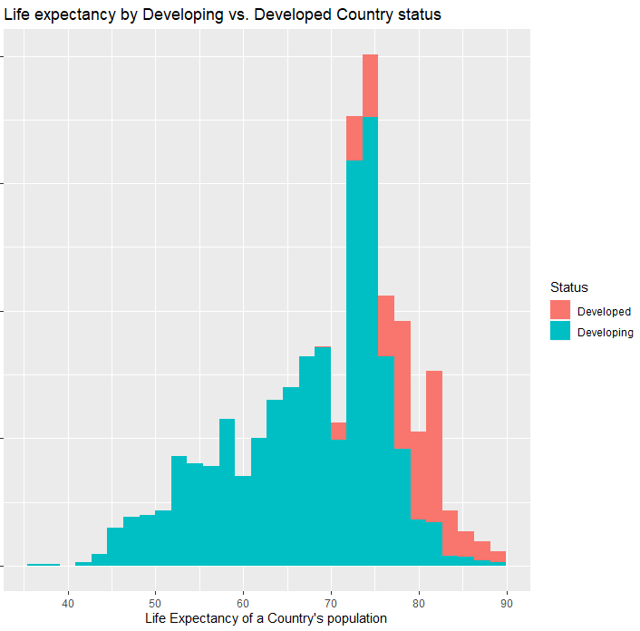

**Correlation:**

Variables that have significant correlation with Life Expectancy: Schooling(0.7276), Income_composition_of_resources(0.7211) , Adult Mortality (-0.7025), HIV_AIDS( -0.5922), BMI(0.5420), thinness_1_19_years(-0.4578), thinness_5_9_years(-0.4575) ), GDP(0.4413), percentage_expenditure(0.4096), Alcohol (0.4027), Diphtheria(0.3413 ) and Polio(0.3273).

Variables that are highly correlated to each other: infant_deaths and under_five_deaths at 0.9969; GDP and percentage_expenditure at 0.9593; thinness_5_9_years and thinness_1_19_years at 0.9279; Schooling and Income composition of resources at 0.7847.

Objective 1: Build and compare data models to predict life expectancy of a country’s population.

1. Simple and highly interpretable model:

**Model** 1: Building model 1 using variables with correlation with Life Expectancy. Running GLM, variable Alcohol proves to be statistically insignificant. Thus, it was removed from the model.

Life_Expectancy = $β0$ + $β1Adult_Mortality$ + $β2HIV_AIDS$ + $β3BMI$ + $β4thinness_1_19_years$ + $β5GDP$ + $β6Diphtheria$ + $β7Polio$ + $β8Schooling$

**Model 2**: Looking at the residuals from Model 1, it makes sense to add log transforms to Life_Expectancy and HIV_AIDS variables. Adding log transform, variable BMI became statistically insignificant, it was thus removed from the model.

Log_Life_Expectancy = $β0$ + $β1Adult_Mortality$ + $β2log_HIV_AIDS$ + $β3thinness_1_19_years$ + $β4log_GDP$ + + $β5Diphtheria$ + $β6Polio$ + $β7Schooling$

Comparing the PRESS Statistic (CV) and R-sq for both the models.

|  |  |  |  |
| --- | --- | --- | --- |
| **Model** | **PRESS STATISTC (CV)** | **R-sq** | **Adj R-sq** |
| Model 1 | 41012.174 | 0.8218 | 0.8212 |
| Model 2 | 8.48 | 0.8454 | 0.8449 |

Fitting model 2: As Model 2 has significantly lower PRESS Statistic, Model 2 is considered better.

Mean(Log_Life_Expectancy|=

3.972903921-0.000230961*Adult_Mortality -0.041370168log_HIV_AIDS - 0.002062371* thinness_1_19_years **+** 0.007546849*log_GDP **+** 0.000397376*Diphtheria **+** 0.000213914*Polio **+** 0.012198913*Schooling

1. Interpretation: According to Model 2, Life_Expectancy of a country’s population is related to the following variables in below described ways:

Though, it is not practical, but if all the factors considered on this model are 0, Life Expectancy of a country’s population will e3.972903921 = 53.13.

Adult_Mortality: Keeping all other factors constant, it is estimated that, a one unit increase in Adult_Mortality is associated with a ( $e^{-0.000230961}$ = 0.999769066) 0.023% decrease in median Life_Expectancy. 95% confidence interval for this decrease is between ( $e^{-0.000206568}$ = 0.999793) 0.021% and ( $e^{-0.000255354}$ = 0.999744679) 0.026%.

HIV_AIDS: Keeping all other factors constant, it is estimated that, a doubling of HIV_AIDS is associated with a $(2^{- 0.041370168}$ =0.959473898) 4.053% decrease in median Life_Expectancy. 95% confidence interval for this decrease is between ( $2^{-0.039309427}$ = 0.961453) 3.855% and ( $2^{-0.04343098}$ = 0.957498707) 4.25%.

thinness_1_19_years: Keeping all other factors constant, it is estimated that, a one unit increase in thinness_1_19_years is associated with a ( $e^{-0.002062371}$ = 0.997939754) 0.206% decrease in median Life_Expectancy. 95% confidence interval for this decrease is between ( $e^{-0.001466004}$ = 0.99853507) 0.146% and ( $e^{-0.002658737}$ = 0.997344794) 0.266%.

GDP: Keeping all other factors constant, it is estimated that, keeping all other factors constant, a doubling of GDP is associated with a $(2^{0.007546849}$ =1.007575398) 0.758% increase in median Life_Expectancy. 95% confidence interval for this decrease is between ( $2^{0.0059571}$ = 1.005974879) 0.597% and ( $2^{0.009136598}$ = 1.009178464) 0.918%.

Diphtheria: Keeping all other factors constant, it is estimated that, Keeping all other factors constant, a one unit increase in Diphtheria is associated with a ( $e^{0.000397376}$ = 1.000397455) 0.04 % increase in median Life_Expectancy. 95% confidence interval for this decrease is between ( $e^{0.000258171}$ = 1.000258204) 0.026% and ( $e^{0.000536581}$ = 1.000536725) 0.054%.

Polio: Keeping all other factors constant, it is estimated that, Keeping all other factors constant, a one unit increase in Polio is associated with a ( $e^{0.012198913}$ = 1.000213937) 0.021 % increase in median Life_Expectancy. 95% confidence interval for this decrease is between ( $e^{0.000074262}$ = 1.000074265) 0.007% and ( $e^{0.000353565}$ = 1.000353628) 0.035%.

Schooling: Keeping all other factors constant, it is estimated that, Keeping all other factors constant, a one unit increase in Schooling is associated with a ( $e^{0.012198913}$ = 1.012273623) 1.227 % increase in median Life_Expectancy. 95% confidence interval for this decrease is between ( $e^{0.011117162}$ = 1.011179187) 1.18% and ( $e^{0.013280664}$ = 1.013369244) 1.337%.

1. Complex model (Model3): After running feature selection techniques and adding interaction with the variable ‘Status’, below is the model we have:

Log_Life_Expectancy(for Countries with Status=’Developing’) = $β0$ + $β1log⁡_HIV_AIDS+ β2Schooling$ + $β3Adult_Mortality$ + $β4Income_composition_of_resources$ + $β5log_percentage_expenditure$ + $β6Diphtheria$

Log_Life_Expectancy(for Countries with Status=’Developed’) = $β0$ + $β1log⁡_HIV_AIDS+ β2Schooling$ + $β3Adult_Mortality$ + $β4Income_composition_of_resources$ + $β5log_percentage_expenditure$ + $β6Diphtheria$ + $β7Income_compos*Status Developed$

**Comparing models**

Comparing the PRESS Statistic (CV) and R-sq for model 2 and Model 3.

|  |  |  |  |
| --- | --- | --- | --- |
| **Model** | **PRESS STATISTC (CV)** | **R-sq** | **Adj R-sq** |
| Model 2 | 8.48 | 0.8454 | 0.8449 |
| Model 3 (with interaction) | 7.78 | 0.8502 | 0.8497 |

Model 3 is the preferred model for the following reasons:

1. From Figure 1, we can see that the ‘Status’ of a country strongly affects the Life expectancy of its population. Model 3 takes this into account.
2. Model 3 has better CV statistics, R-sq and Adjust R-sq.
3. Model 3 has fewer variables with log transforms, so it is easier to interpret.

**Fitting model 3:**

Mean(Log_Life_Expectancy{for Countries with Status=’Developing’}) = 3.972351146 $-0.041640209*log_HIV_AIDS*+ 0.008289124*Schooling$-0.000211583 $*Adult_Mortality$ + 0.104705191 $*Income_composition_of_resources$ + $0.006853873*log_percentage_expenditure$ + $0.000473442*Diphtheria$

Mean(Log_Life_Expectancy{for Countries with Status=’Developed’}) = 3.972351146 $-0.041640209*log_HIV_AIDS-+ 0.008289124*Schooling$ + $-0.000211583*Adult_Mortality$ + 0.104705191 + + +

2) Objective2 : KNN

**Final Conclusion:**

**Conclusion:**

**Factors where more time could have been spent:**

1. **Data Cleanse – Missing values could have been replaced by more sensible values.**
2. **Analyze other non-parametric models.**

Appendix:

LED <-read.csv(file.choose())

Reading the structure of the data

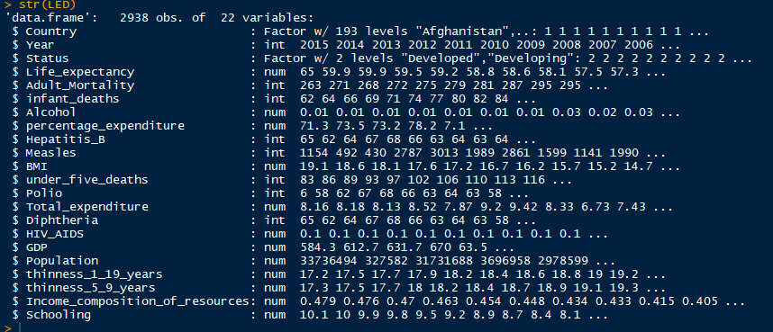

Reading the summary of the data

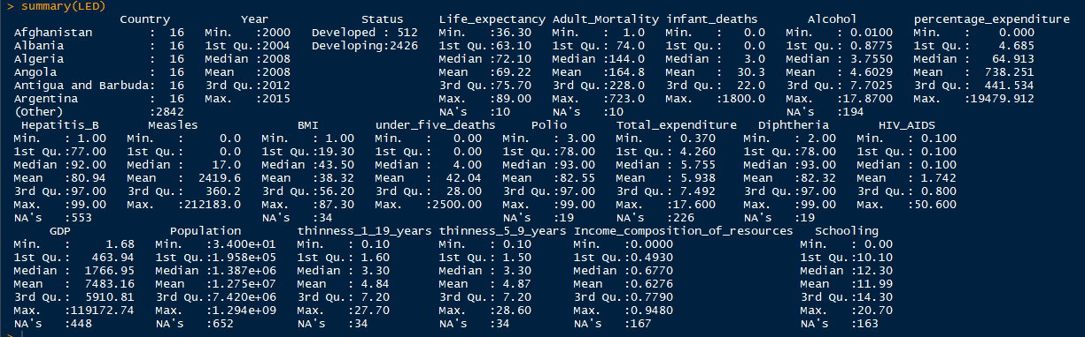

Some similar analysis in SAS

**proc** **means** data=LED n mean max min range std;

output out=meansout mean=mean std=std;

title 'Summary of LifeExpectancyData';

**run**;

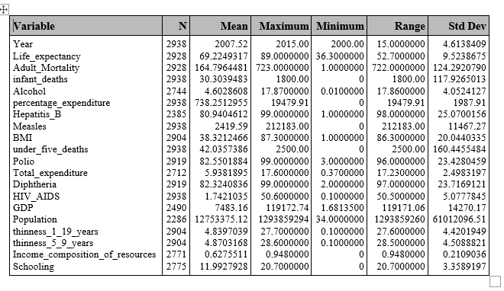

#Missing data

LED %>% filter(is.na(Life_expectancy))

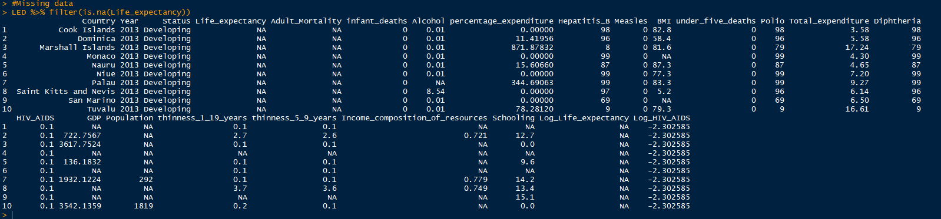





Scatter Plots:

plot(LED[,c(4,5,6,7,8,9,10,11)])

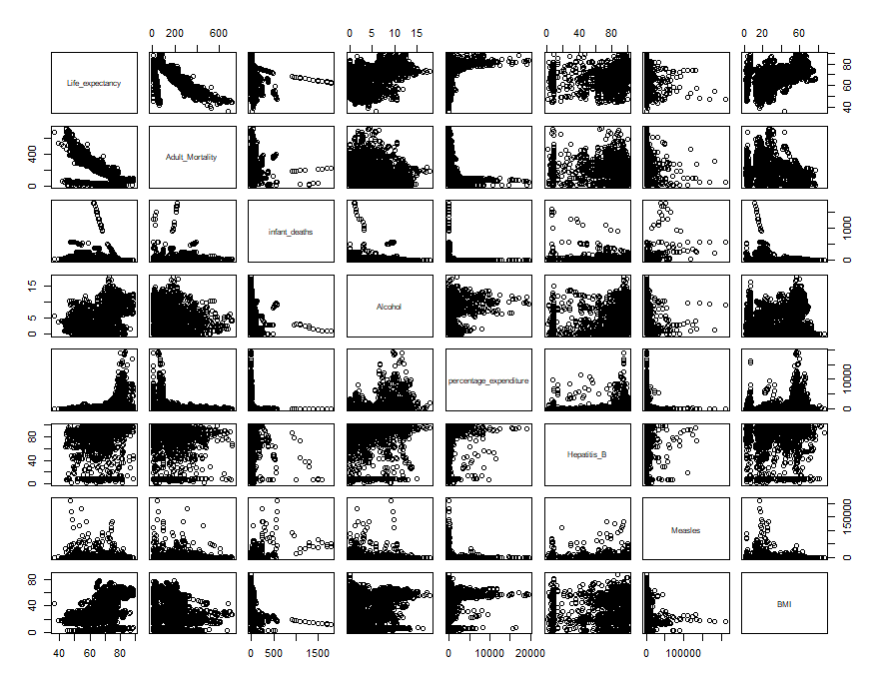

plot(LED[,c(4,12,13,14,15,16,17,18)])

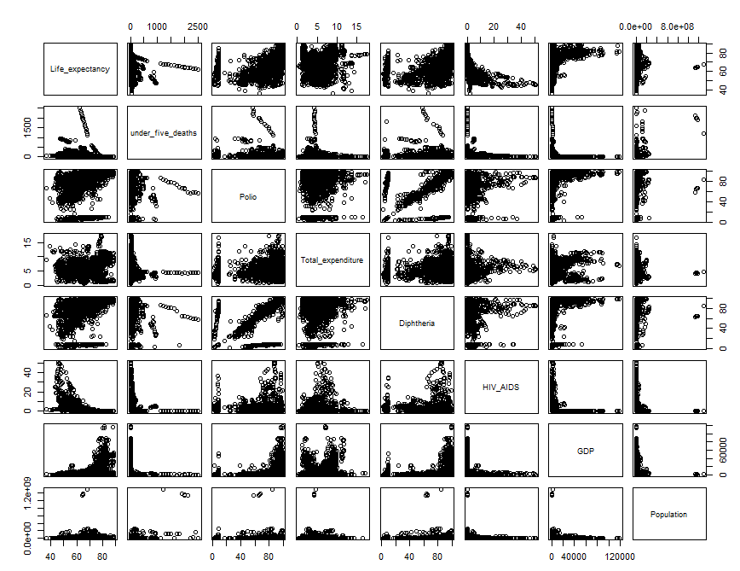

plot(LED[,c(4,19,20,21,22)])

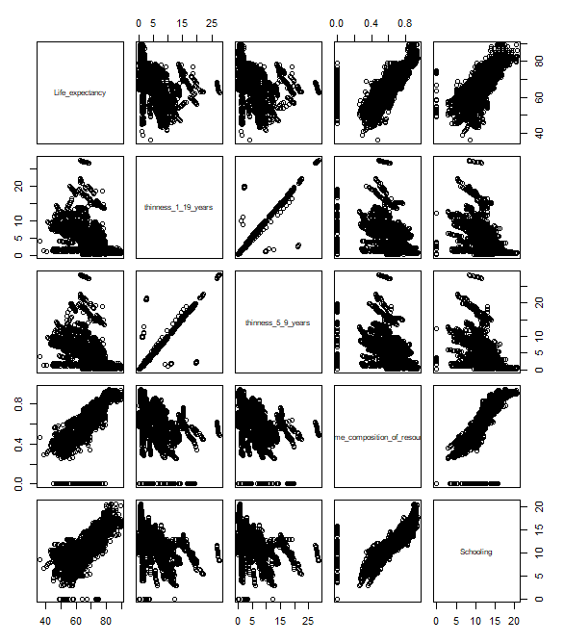

**Correlation:**

**proc** **reg** data=LED corr plots(label) = (rstudentleverage cooksd);

model Life_expectancy= Year Adult_Mortality infant_deaths Alcohol percentage_expenditure Hepatitis_B Measles BMI under_five_deaths Polio Total_expenditure Diphtheria HIV_AIDS GDP Population thinness_1_19_years thinness_5_9_years Income_composition_of_resources Schooling / VIF;

**run**; **quit**;

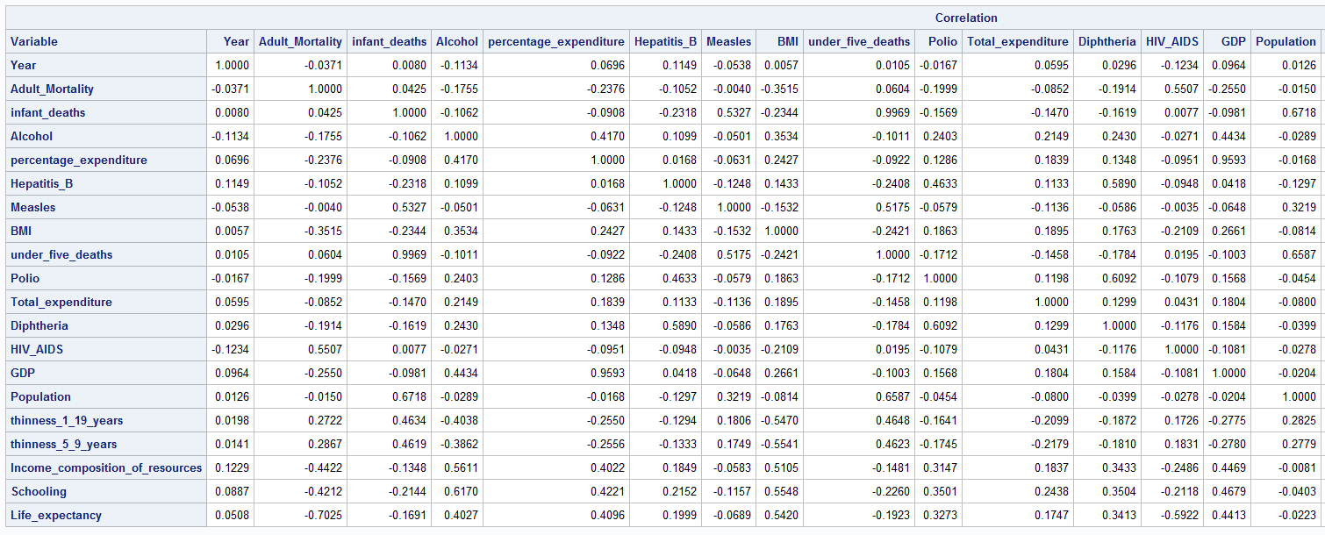

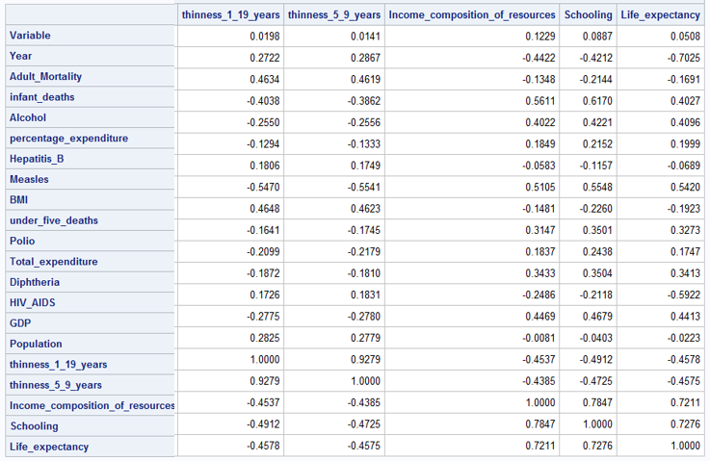

Models:

**proc** **reg** data=LED corr plots(label) = (rstudentleverage cooksd);

model Life_expectancy= Year Adult_Mortality infant_deaths Alcohol percentage_expenditure Hepatitis_B Measles BMI under_five_deaths Polio Total_expenditure Diphtheria HIV_AIDS GDP Population thinness_1_19_years thinness_5_9_years Income_composition_of_resources Schooling / VIF;

**run**; **quit**;

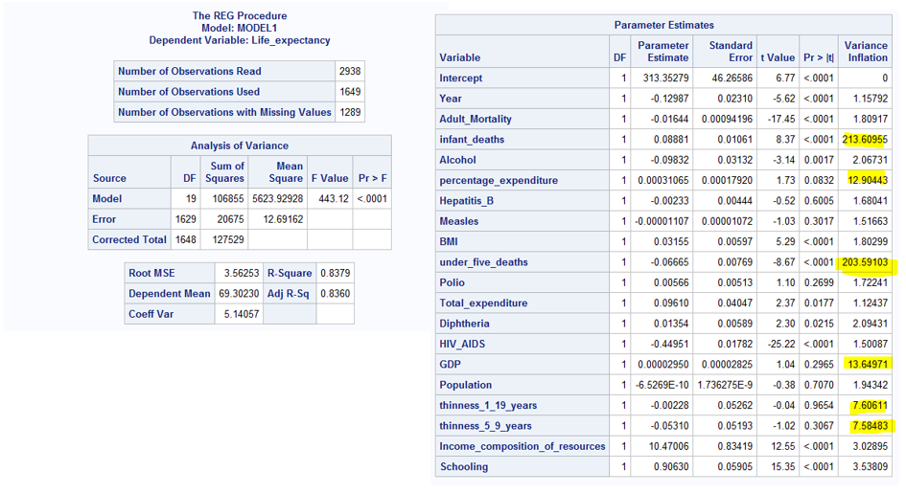

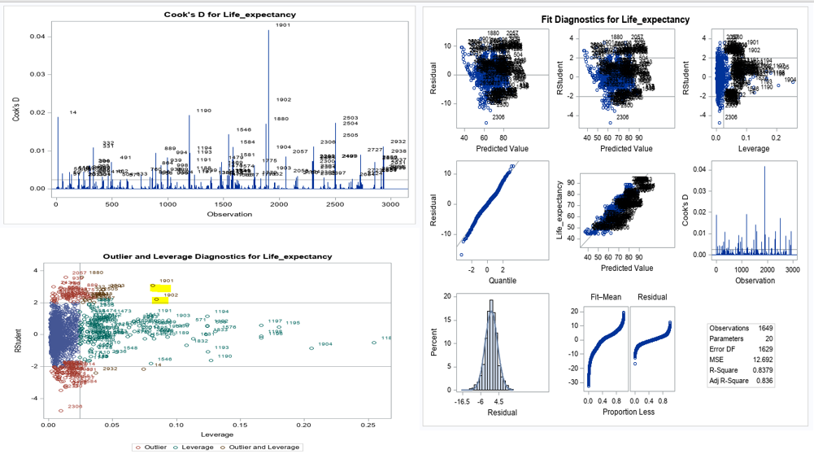

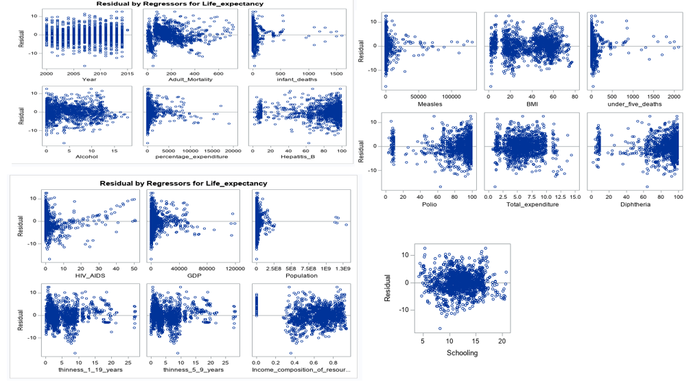

*Important observations;

*1) infant_deaths and under_five_deaths are highly correlated at 0.9969. Take infant_deaths out;

*2) GDP and percentage_expenditure are highly correlated at 0.9593. Take GDP out ;

*3) thinness_5_9_years and thinness_1_19_years 0.9279. Take thinness_5_9_years out;

*4) What do we do about under_five_deaths and Diphtheria? From VIFs, it looks like there's a correlation among these, but looking at the correlation factors above, we see it is -0.1784. So, we can keep them both in the model;

* Take infant_deaths,percentage_expenditure and GDP out and check VIFs;

**proc** **reg** data=LED corr plots(label) = (rstudentleverage cooksd);

model Life_expectancy= Year Adult_Mortality Alcohol percentage_expenditure Hepatitis_B Measles BMI under_five_deaths Polio Total_expenditure Diphtheria HIV_AIDS Population thinness_1_19_years Income_composition_of_resources Schooling / VIF;

**run**; **quit**;

* Looking at the residual plots, it feels necessary to do some transformations.;

**data** LED;

SET LED;

log_Life_expectancy = log(Life_expectancy);

log_percentage_expenditure = log(percentage_expenditure);

log_Adult_Mortality = log(Adult_Mortality);

log_Hepatitis_B = log(Hepatitis_B);

log_Measles = log(Measles);

log_BMI = log(BMI);

log_under_five_deaths = log(under_five_deaths);

log_Polio = log(Polio);

log_Total_expenditure = log(Total_expenditure);

log_Diphtheria = log(Diphtheria);

log_HIV_AIDS = log(HIV_AIDS);

log_Population = log(Population);

log_GDP = log(GDP);

**run**;

**proc** **reg** data=LED corr plots(label) = (rstudentleverage cooksd);

model log_Life_expectancy= Year Adult_Mortality Alcohol log_percentage_expenditure log_GDP Hepatitis_B log_Measles BMI log_under_five_deaths Polio Total_expenditure Diphtheria log_HIV_AIDS log_Population thinness_1_19_years Income_composition_of_resources Schooling / VIF;

**run**; **quit**;

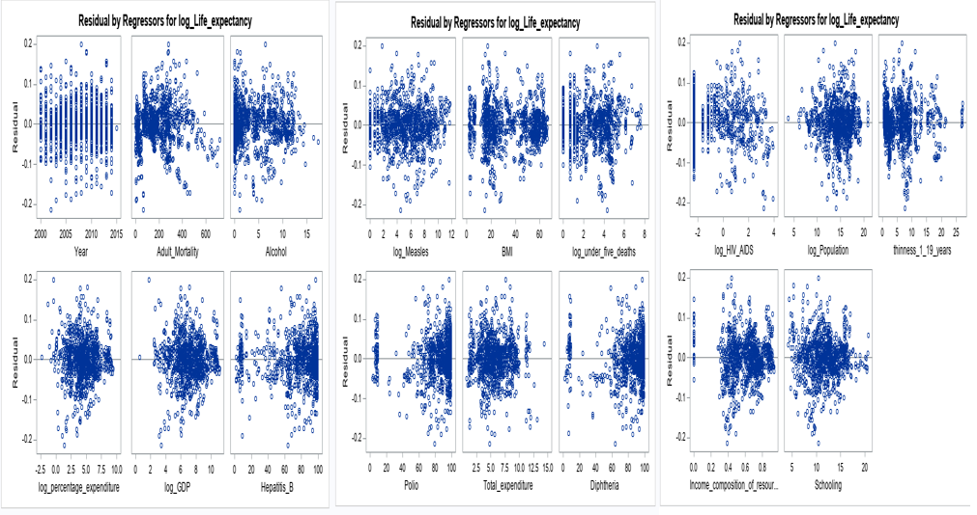

Model 1: Using variables with high correlation to Life_Expectancy

**PROC** **GLM** DATA= LED plots = all;

title "Model 1 WITH VARIABLES with correlation to Life_Expectancy ";

class Status;

model Life_expectancy = Adult_Mortality HIV_AIDS BMI thinness_1_19_years GDP Alcohol Diphtheria Polio Schooling / solution ;

output out = Customsel ;

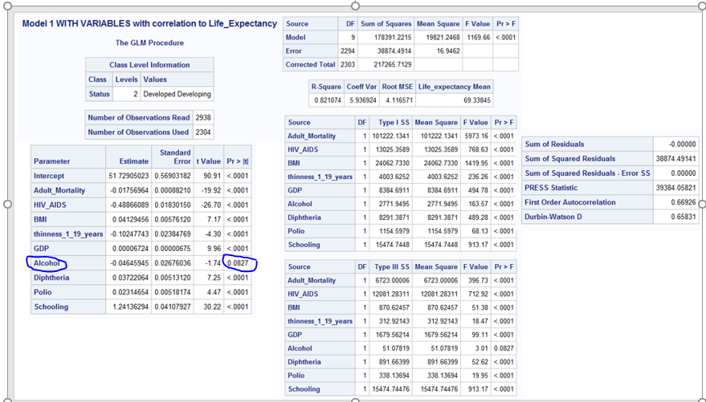

Variable Alcohol being statistically insignificant, removing it from the model.

**Revised Model1**

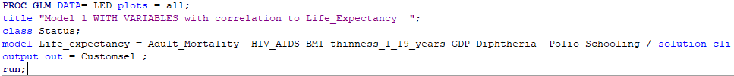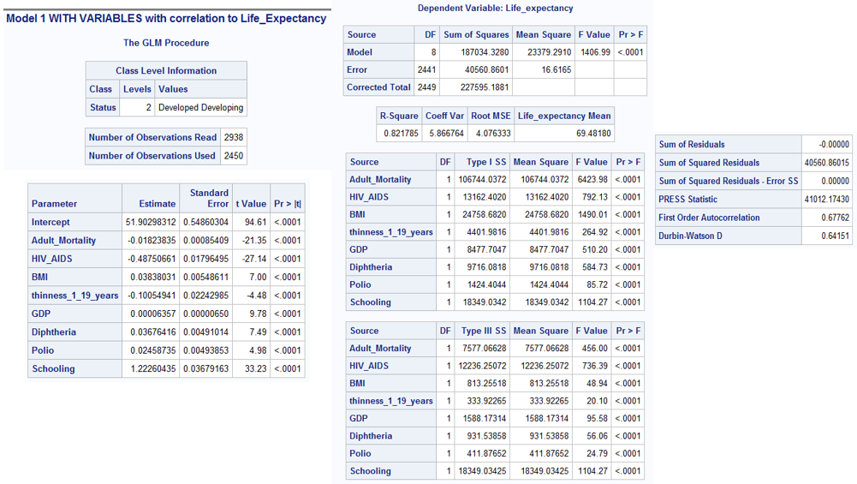

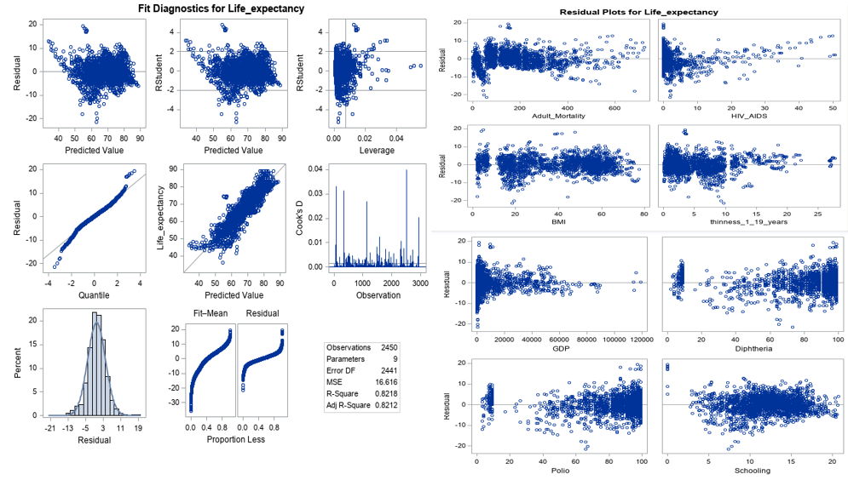

**Model2**: After taking log on Life_Expectancy, HIV_AIDS and GDP.



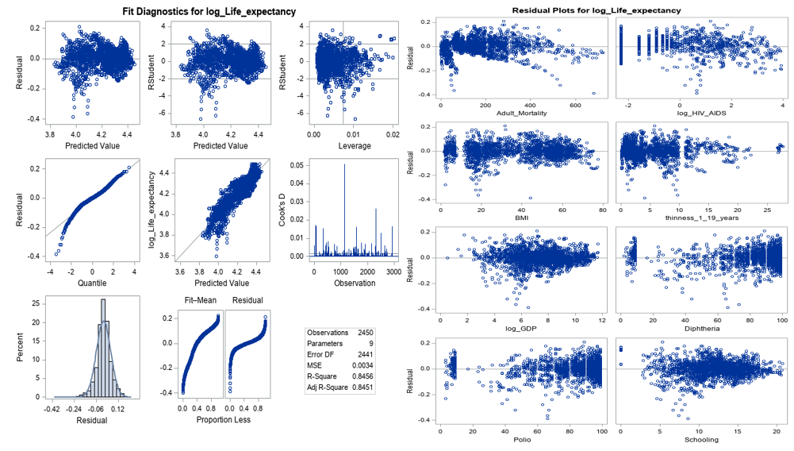

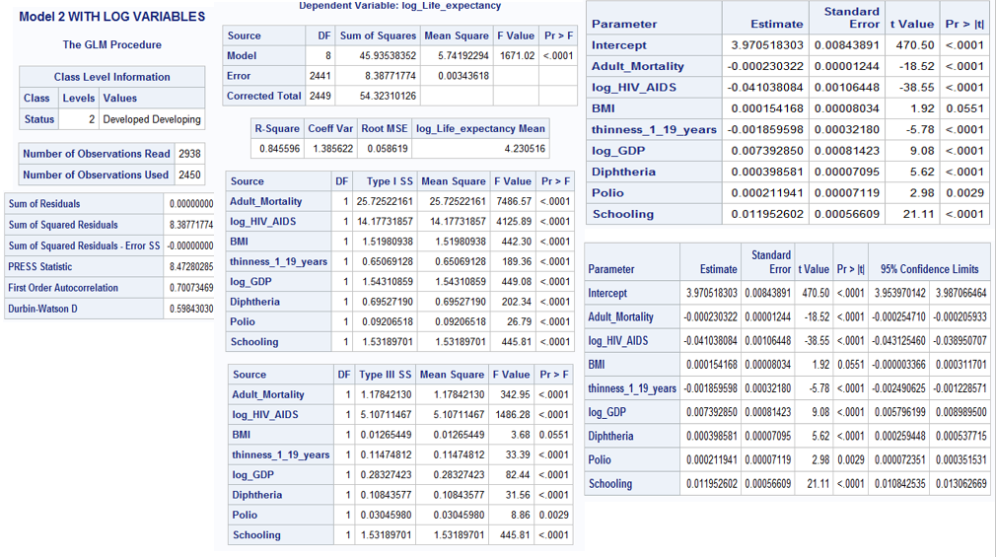

**Revised Model 2:** After taking log transform, BMI becomes statistically insignificant. Revising the model to remove BMI as a model parameter.



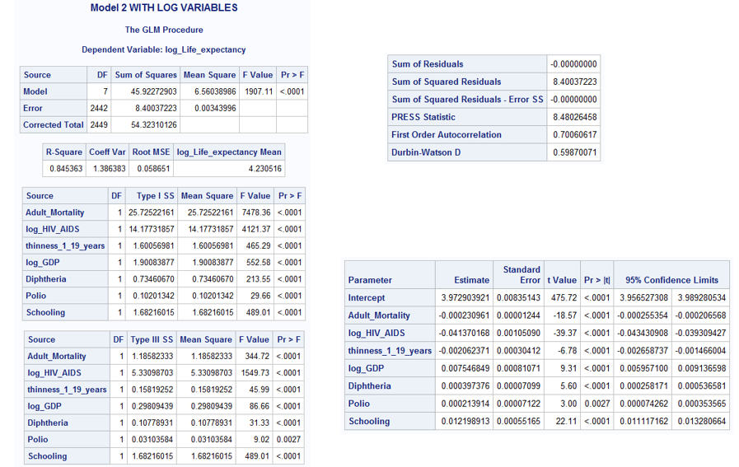

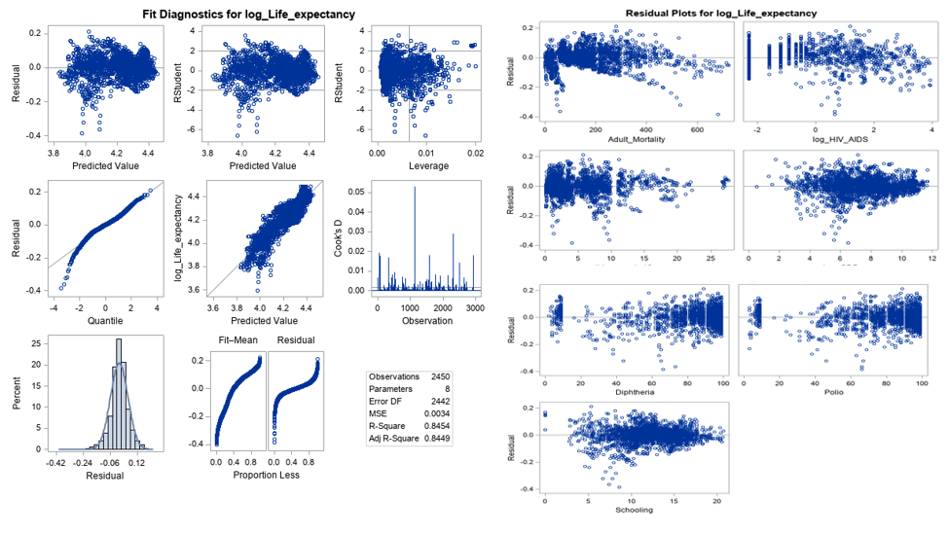

**Finding a complex model: Run models using different feature selection techniques (primarily CV)**

* Model assesment using ASE;

*Run different models using partition fraction(test = .7) and ASEPlots ;

**PROC** **GLMSELECT** DATA= LED plots(stepaxis = number) = (criterionpanel ASEPlot) seed = **1**;

title "**Forward** selection using CV Press as stop criteria with ASE";

partition fraction(test = **.5**);

class Status;

model log_Life_expectancy= Year Adult_Mortality Alcohol log_percentage_expenditure Hepatitis_B log_Measles BMI log_under_five_deaths Polio Total_expenditure Diphtheria log_HIV_AIDS log_Population thinness_1_19_years Income_composition_of_resources Schooling / selection = Forward(stop=CV);

output out = Forwardsel ;

**run**;

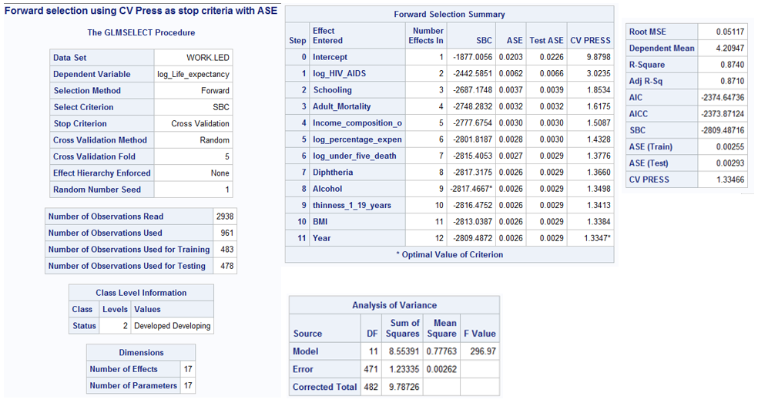

**PROC** **GLMSELECT** DATA= LED plots(stepaxis = number) = (criterionpanel ASEPlot) seed = **1**;

title "**Backward** selection using CV Press as stop criteria with ASE";

partition fraction(test = **.5**);

class Status;

model log_Life_expectancy= Year Adult_Mortality Alcohol log_percentage_expenditure Hepatitis_B log_Measles BMI log_under_five_deaths Polio Total_expenditure Diphtheria log_HIV_AIDS log_Population thinness_1_19_years Income_composition_of_resources Schooling / selection = backward(stop=CV);

output out = Backwardsel ;

**run**;

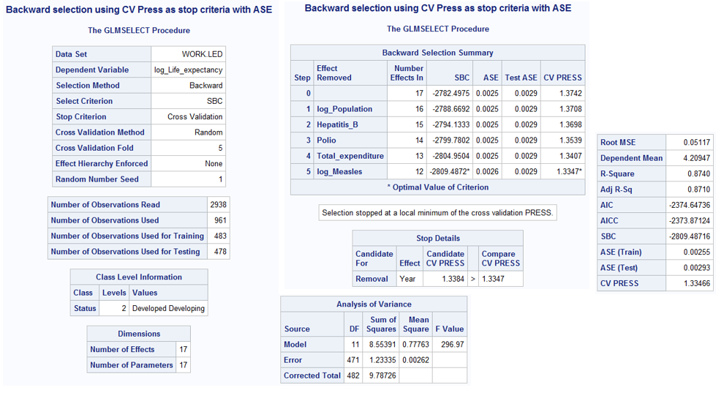

**PROC** **GLMSELECT** DATA= LED plots(stepaxis = number) = (criterionpanel ASEPlot) seed = **1**;

title "**Stepwise** selection using CV Press as stop criteria with ASE";

partition fraction(test = **.5**);

class Status;

model log_Life_expectancy= Year Adult_Mortality Alcohol log_percentage_expenditure Hepatitis_B log_Measles BMI log_under_five_deaths Polio Total_expenditure Diphtheria log_HIV_AIDS log_Population thinness_1_19_years Income_composition_of_resources Schooling / selection = Stepwise(stop=CV);

output out = Stepwisesel ;

**run**;

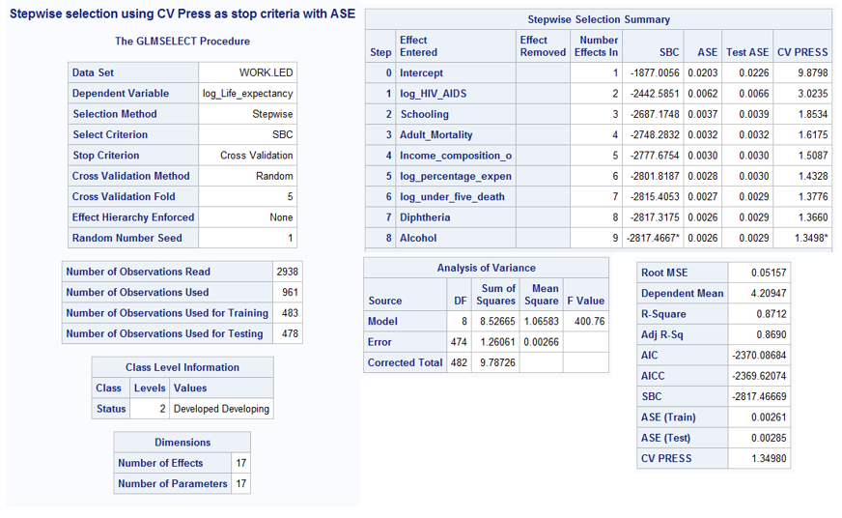

**PROC** **GLMSELECT** DATA= LED plots(stepaxis = number) = (criterionpanel ASEPlot) seed = **1**;

title "**LASSO** selection using CV Press as stop criteria with ASE";

partition fraction(test = **.5**);

class Status;

model log_Life_expectancy= Year Adult_Mortality Alcohol log_percentage_expenditure Hepatitis_B log_Measles BMI log_under_five_deaths Polio Total_expenditure Diphtheria log_HIV_AIDS log_Population thinness_1_19_years Income_composition_of_resources Schooling / selection = lasso( choose = cv) CVDETAILS;

output out = LASSOsel ;

**run**;

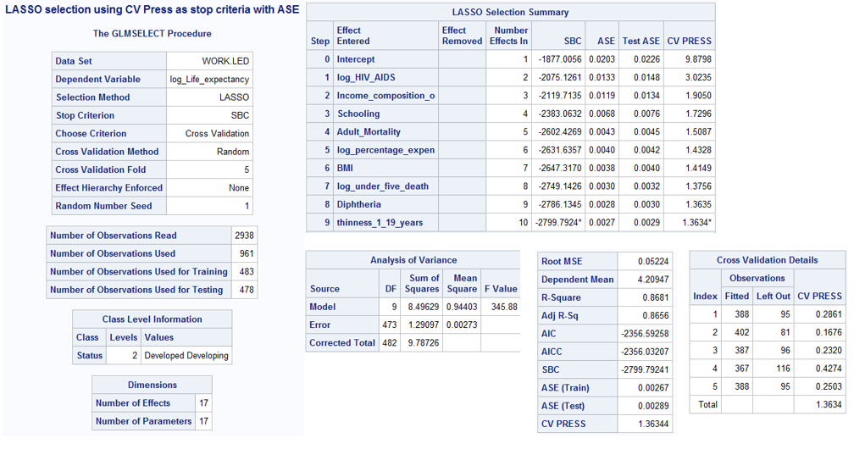

**PROC** **GLMSELECT** DATA= LED plots(stepaxis = number) = (criterionpanel ASEPlot) seed = **1**;

title "**LARS** selection using CV Press as stop criteria with ASE";

partition fraction(test = **.5**);

class Status;

model log_Life_expectancy= Year Adult_Mortality Alcohol log_percentage_expenditure Hepatitis_B log_Measles BMI log_under_five_deaths Polio Total_expenditure Diphtheria log_HIV_AIDS log_Population thinness_1_19_years Income_composition_of_resources Schooling / selection = lars( choose = cv) CVDETAILS;

output out = LARSsel ;

**run**;

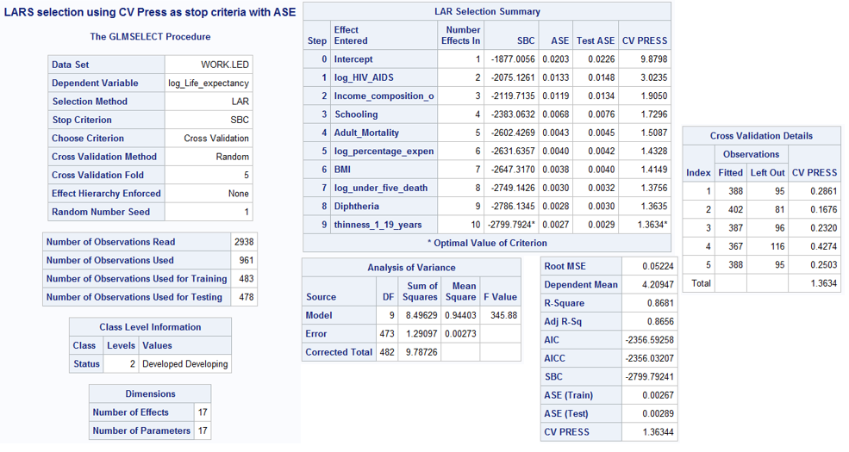

Both, Forward and Backward, selection methods have the least CV PRESS and ASE -Train and Test. Looking at the variables selected by each of the models, I will go ahead with the creating a custom model using the variables selected by ‘Forward selection’.

Custom Model:

**PROC** **GLM** DATA= LED plots = all;

title "Custom Model with variables selected from Forward model with STATUS interaction ";

class Status;

model log_Life_expectancy = log_HIV_AIDS Schooling Adult_Mortality Income_composition_of_resources log_percentage_expenditure log_under_five_deaths Diphtheria Alcohol thinness_1_19_years BMI log_HIV_AIDS*Status Schooling*Status Adult_Mortality*Status Income_composition_of_resources*Status log_percentage_expenditure*Status log_under_five_deaths*Status Diphtheria*Status Alcohol*Status thinness_1_19_years*Status BMI*Status / solution clparm ;

output out = Customsel ;

**run**;

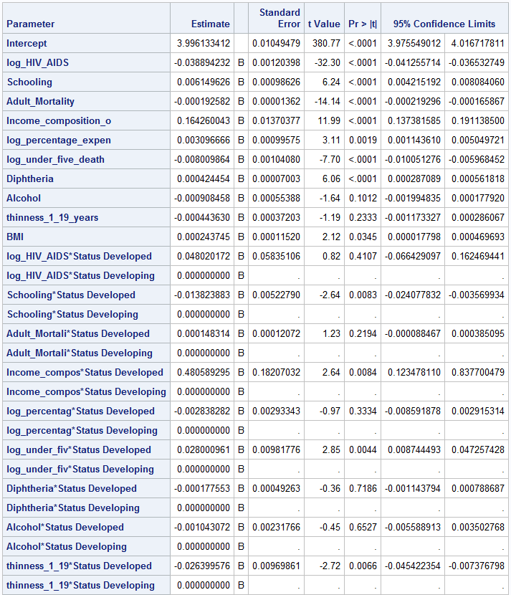



Removing all the statistically insignificant variables from the model:

**Revised Customer Model**

**PROC** **GLM** DATA= LED plots = all;

title "Custom Model with variables selected from Forward model with STATUS interaction ";

class Status;

model log_Life_expectancy = log_HIV_AIDS Schooling Adult_Mortality Income_composition_of_resources log_percentage_expenditure Diphtheria Income_composition_of_resources*Status / solution cli clparm ;

output out = Customsel ;

**run**;

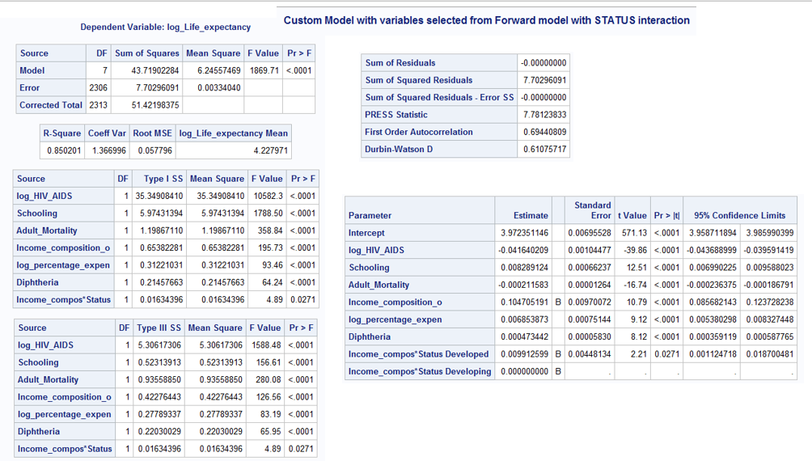

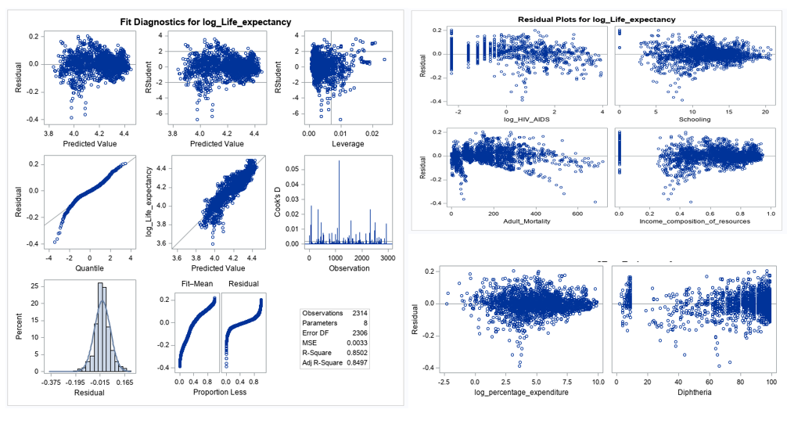

Objective 2

Knn

KNN does not allow any missing variables, hence use all cleansed data set.